### Favorite tower defense

BLOONS

Bloons

### Favorite shooter game

The House Of The Dead

Halo 4

### Platformer

New Super Mario Bros.

Prince of Persia

### Puzzle/Adventure

The Walking Dead

Portal 2 / Zelda

## Bloons

Setting

No specific setting. The game consists of multiple maps. In general, these maps look happy. The setting is always in daylight and the art style looks cartoonish.

## New Super Mario Bros

Plot

Mario (or Luigi) goes for a walk with Princess Peach. When lightning hits Princess Peach’s castle, Mario checks it out to see what’s going on. While he is gone, Princess Peach gets kidnapped by Bowser Jr. Mario notices the disappearance of the Princess and chases them.

Mario has to go through eight different worlds with ten levels in each to get to the Princess. Each world consists of one small castle with a boss to beat and a big castle with a harder boss to beat.

Eventually he reaches the end of the eight world and defeats Bowser. He rescues Peach.

## Portal 2

Narrative:

The player’s story starts with information given to them by a talking AI named Wheatly, indicating the game is set in the future. As the player progresses Wheatly accompanying the player gives hints that they are in an overgrown testing facility. This was indicated before by visual since the starting room was partially destroyed, enabling the player to see the magnitude of the facility. Throughout the game, the player gets taunted by the AI running the facility, Glados. Glados’ voice is very mechanical, though Wheatly’s is more natural, which tells the player Wheatly was created after Glados.

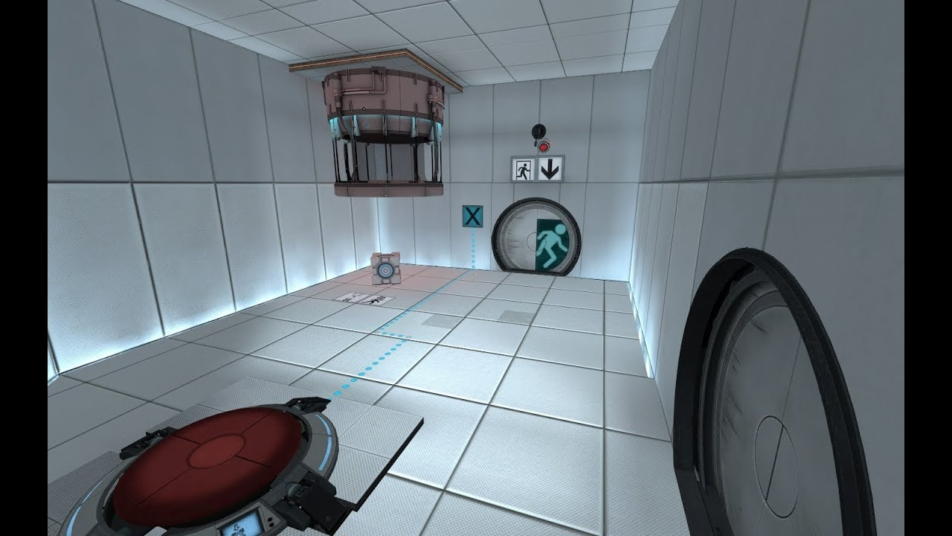

Because the music and sounds are very mechanical as well, and could be called eerie, the player’s feeling of being threatened by Glados is amplified. Both AIs participate in giving the player the storyline, bit by bit.

Regarding the simplistic aesthetics, the environment takes a role in giving the player the ‘being tested’ ambiance the whole game is about.

## Extensive analysis: The House of the Dead

### Genre

FPS.

### UX

For us, the game is very fast paced, yet simple controls make up for it. One issue we immediately experienced is the sensitivity of the aiming.If that could be dialed down a notch, it would make aiming easier, improving accuracy. As accuracy plays a big part in the game, for instance weak spots, aiming is crucial for the user’s experience. As far as the user interface goes, the game makes it very clear how many health points you have, indicated by the candles on the bottom corner. The remaining amount of bullets before reloading is also clear. Because each player has its ‘own’ color (red for P1, blue for P2) there is no confusion regarding who is player 1 and who is player 2.

### Storytelling

Before the player starts the game, they are shown a quick intro, which provides a little amount of backstory. As the player progresses, they get more information. This means the game is providing the story. For the global picture however, the story is used to enhance the gameplay, for instance a cutscene that shows a mad scientist creating zombies to kill everyone.

### Narrative

As mentioned in the storytelling, the game starts with cutscenes, introducing the player to the main characters. The red line of the game is told either by the scientists talking to the player’s character or visuals, for instance a scientist viciously being thrown off a bridge.

### Plot

Agent Rogan received an emergency call from Sophie Richards, his fiancee. She tells him Dr. Curien experiments on life and death. And his experiments have gone too far and have taken a different turn. His mansion, The Curien Mansion, experiences an outbreak of undead creatures. Killing everyone in their way. Also the working scientist. The player, either playing as Agent Rogan or Agent “G” (his partner), are headed to The Curien Mansion to stop his experiments and save Sophie and as many scientists as possible.

When arriving at the Mansion, a dying scientist gives the player all the information and weaknesses on the creatures Curien has built. After that, the agent sees Sophie, but she gets taken away by the creature called *The Hangedman*. Later on, the agents find Sophie again, but she gets attacked by *The Chariot*. After the player defeats this monster, Sophie tells him that the agent “must stop Curien’s plans, or else something terrible will happen”.

The player then proceeds to kill the *Hangedman* and *The Hermit*.

Arriving at the mansion’s laboratory, Curien shows his true masterpiece, *The Magician*. A creature with pyrokinetic abilities. *The Magician* refuses to listen to Curien’s orders and kills Curien, leaving the player to end this creature. The agent kills it successfully and leaves the mansion.

### Theme

Zombie / Experimental

### Setting

There’s multiple settings in the game, due to the game having multiple “chapters” and routes. Chapter 1 is set outside of the mansion and also a little bit inside of the mansion. The sky makes it look like a creepy mansion. The front yard is full of dead plants which make the setting look abandoned. There’s a broken down structure in the middle of the yard, that used to be a fountain. There’s this huge bridge that connects the front yard to the mansion, decorated with small dracula’s. Just like the fountain.

Inside the house there are small corridors and lifts to use.

### Mood

The game is about zombies, rescuing a woman, so the player gets a heroic vibe. The game mainly consists of either rectangular shapes or triangles, amplifying the hostility in the player’s surroundings. The fast music and the music being fantasy based provide the feeling of a time limit. Sound effects include shots being fired, zombie growls and the screaming of scientists and others, which contribute to an eerie feeling and a sense of horror even. Dialogues are mainly used to guide the player towards the target / goal of the level. Colors are mainly dark, providing even more sorrow and hostility.

### Point of view

The game is played from a first person point of view, hence the genre FPS. The idea of the player being the character enhances the mood and overall user experience, ie. it’s the player rescuing scientists, it’s the player shooting the zombies and it’s the player killing the bosses. For cutscenes however, the point of view is third person, which is used to describe more about what is going on with the player’s character. This viewpoint also provides more information about the player’s surroundings.

Kingdom’s Saviour

## Game Summary

There’s a dragon terrorising the castle for ages. The king / queen has decided that the evil monster has to be slayed to free the kingdom and return peace to the lands. You, the chosen hero to fulfill this quest, have to go through many obstacles and monsters in order to travel to the dragon’s lair. On your quest you will find items, explore the environment and collect weapons to help you on your way.

## Game Outline

The player starts in the kingdom, the first level. On the way the player traverses cities, then small villages, forests and eventually a volcano, where the dragon’s lair is located. Enemies can be killed using ranged weapons and close range weapons.

## USP

* Camera movement is automatic
* Easy controls

## Similar Competitive Products

The House of the Dead, Silent Hill: The Arcade

## Main mechanics

Weapon: bow  
Shop → same merchant

Unmovable camera

Health bar instead of health points

The further you go, the more uncivilized (abandoned)

Orcs

More health points (more ammo clips)

## Ideas

Multiple weapons, melee included:

* Crossbow
* Lance
* Spear
* Sword
* Dagger
* Spells

Fire arrows for exploding barrels of gunpowder

Fire arrows could be crafted by flint

Armor

Power-ups

Choosing paths

Puzzles  
Baby dragons as regular enemies or mini bosses  
Concurring heroes

Check out Res. evil

